**4. Application code management using Git**

Create ec2 instances in tow different region virgin and oreogen with separate keypair do in both terminals





What is gitbash ?

How to configure username and email for git

$ git init

$ git config --global user.name "yasmeen"

$ git config --global user.email [yasmeen_aashu@epam.com](mailto:yasmeen_aashu@epam.com)

TO check the configurations

$ git config --global --list

How to make working directory as git repository

$ git init

git init

working directory ------> staging area -------> LR

untracked files

staged files

commited files

+++++++++++++

-Observation –

++++++++++++++++

**Create repository in github**

Choose public

GET https link and paste 

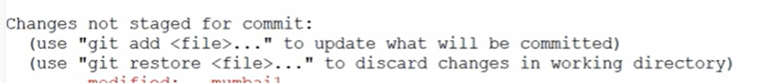

Git pull origin master

